NB: This is a DRAFT Nomination

Name:
Ballast Point Park

Other or former name(s):
Walama ‘to return’

European:
Ballast Point Park

Location
Street address:
Ballast Point Road, Birchgrove, 2041
Alternate street address:

Local government area:
Inner West Council

Land parcel(s):

Lot 1 DP 115939 21410.510sqm

Co-ordinates:

Lat: -33.852268 Long:151.189098

Extent of Nomination

Curtilage map of nominated area:

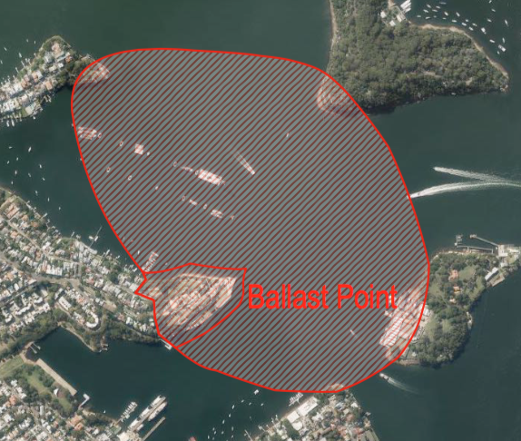
Includes Ronald Street Reserve walkway and trees and the unincorporated green areas around the park and to north-west.

Source of map or plan:
SIX Maps

Boundary description (in words):

The boundary follows a line set offshore in Snails Bay from the park boundary with 3 Wharf Road around Ballast Point to Ballast Point Pier. It then goes up Ronald Street and includes the narrow reserve/walkway which extends from Ballast Point Pier to Wharf Road. From Wharf Road the boundary follows the property boundary of Ballast Point Park back to 3 Wharf Road. The larger hatched boundary is the important visual curtilage of the park.

Ownership

Name of owner(s):
Property NSW
Inner West Council (Ronald Street walkway/reserve)

Contact person:

Contact position:

Postal address:

Phone number:

Owner explanation:

Significance

Why is it important in NSW
Statement of state significance

Ballast Point Park may be of State significance for the accomplished integration of landforms and relics from the site’s former uses into a multi-layered, intellectually challenging and sophisticated public park in a broad setting of exceptional aesthetic appeal. The dialogue between the geometry of the remnant industrial form, raw concrete and gabion walls and recreated nature using local species demonstrates skill and sensitivity. The nuanced interpretation of the former uses of the site demonstrates a high degree of creativity, which is a benchmark in park design in NSW and an exemplar of a 21st century approach to the transformation of remnant industrial sites to public parks.

Ballast Point is of historic significance as the site used to quarry ballast for ships in early colonial Sydney, for its 19th century use as a harbour estate ‘Menevia’, and during the 20th century as a place the local community valued for its distinctive harbourside location and repeatedly campaigned for its preservation as public open space. It is of historic significance for its use from c.1930-1990s as Texaco’s (merged with Socal to form Caltex from 1936) first seaboard terminal in Australia.

Ballast Point has a strong association with Tom Uren and members of the Ballast Point Campaign Committee, who successfully campaigned from the 1970s to 2002 for the land to be dedicated as public open space. It is held in high esteem by the Australian Institute of Landscape Architects.

Comparisons:

The main comparison for Ballast Point is Carradah Park, which was created on the former BP facility at Waverton, by macgregor+coxall in 2003-2005. There the designers utilised similar grassed circles to interpret the previous tank spaces and metal walkways, which are sympathetic to the industrial past of the site.

Carradah Park can be seen as a progression of Mackenzie’s 1970s concept of ‘Alternative Parkland’ for former industrial places converted to parkland. Although the landscape architects also utilised the man made cliff faces associated with the BP terminal at Carradah Park, the overwhelming impression is one of the bushland reclaiming the precipitous site.

At Ballast Point, the use of industrial remnants is more overt, the gabion walls more prominent and the overall impression is a more artistic dialogue between urban, industrial built form and the natural elements of harbour and vegetation. At Ballast Point, it appears that macgregor+coxall were building on the experience at Carradah Park and exploring a new level of artistic interpretation and sustainability–a design that an AILA jury considered one of the 13 best ‘transformative’ projects of the 21st century Australia-wide in 2016.

With respect to community action to ensure the retention of public open space on the harbour the major comparison is Ball’s Head. There the campaign of the 1920s to retain Ball’s Head as public space was successful but a similar campaign at the time for the government to buy Ballast Point failed. However, community endeavours to return Ballast Point to the public were finally successful in 2002, demonstrating the continuity of concern about the issue within the general community.

Description:

Existing place or object
Description:

Ballast Point Park is approximately 2.6 hectares in area at the tip of the peninsula that defines the southern side of Birchgrove. The underlying geology of Ballast Point is Hawkesbury Sandstone and the natural soils of the area are acidic, of low fertility loose quartz sand, underlain by sandy clay loam or light clay.

The main entrances to Ballast Point Park are one opposite the end of Ballast Point Road and another from Wharf Road to the north west side of the park. Ronald Street runs along the western boundary of the park. The Ronald Street access to Ballast Point Pier and its mature fig trees, which provide a buffer between the park and a residential area, comprises part of the nominated SHR listing.

On entering the site from Wharf Road an elegant pavilion of concrete and wood roofed in woven strips of orange webbing by architect Choi Ropiha captures the eye; the pavilion is actually a toilet block. This device of using woven orange webbing is repeated in shade structures in the park.

An interpretation of the former Caltex Tank 101, a large steel sculptural element, which utilises steel from the original tank and with words by poet Les Murray pierced into its circumference, commands the high point of the park. Wind turbines on the structure generate power for the site. Sustainability was a driving force in the design process and there is evidence of remnants of the site’s past re-used throughout the site. Waste water is captured and filtered onsite before being discharged into the harbour.

The underlying worked sandstone, sandstone cliffs and massive concrete walls associated with the former use of the site by Caltex are the topographical elements that define and divide the site. The Park is arranged as a series of stepped platforms with more intimate spaces forming microclimates. The south east side of the Park is exposed to the harbour with wide views of nearby Goat Island and the harbour setting through an open replanted forest. The north side of the park contains the more sheltered spaces.

The vegetation throughout the site recreates, as far as it has been possible, the original flora of the area. Tree species are Angophora costata, Allocasuarina littoralis, Banksia integrifolia, Callistemon citrinus, Corymbia gummifera, Casuarina glauca, Callicoma serratifolia, Eucalyptus haemastoma, Eucalyptus pilularis, Eucalyptus punctata, Elaeocarpus reticulatus, Ficus macrophylla, Ficus rubiginosa, Glochidion ferdinandi, Tristaniopsis laurina and Melaleuca linearifolia.

The shrubs used vary according to the differing precincts – ridge area, sandstone open forest and the sheltered open forest.

Lomandra longifolia, Carex appressa and Gahnia melanocarpa are the native grasses and sedge used throughout the site.

Spaces are traversed by a series of metal ramps, bridges and stairs. In some parts of the site huge gabion walls filled with rubble from the reshaping of the site provide further interest with the addition of broken pieces of pottery and artefacts excavated from the site and mementos from construction workers.

The footprint of ‘Menevia’ the mansion that stood from 1864 to 1930 on the high ground of the Point is marked in black enamelled steel panels that contain bottles, crockery and glassware found during excavation. Interpretation of the 19th century use of the site is centred in this location.

Steel rings defining grassed circles, mark the location of the tanks formerly used as part of the Caltex Oil complex.

Views from the Park to Sydney Harbour Bridge, Balls Head, Goat Island (Me Mel), Barangaroo, Balmain and back up the Parramatta River to Yurulbin and the north side of the Harbour are part of the aesthetic experience of the site. On the lower edge to the south east is a sculpture called ‘Delicate Balnce’ and concrete structure which resembles a large angled tube or shaft.

Condition of fabric and or/ archaeological potential:
Very good

Integrity / intactness:
Grade the significance of fabric and its intactness.
High

Modifications date:
2007-2009

Date you inspected the place for this description:
2016.

Current use:
Harbourside parkland

Original or former use:
Site for fishing and extracting ballast
Marine villa and estate
Caltex Oil refinery

Further comments:

Historical outline:

Origins and historical evolution

Years of construction:

1864-1928 ‘Menevia’ marine villa

1928-1990s Texaco and Caltex Oil

2007-2009 Construction of Ballast Point Park

Designer / architect:
Landscape architect: McGregor Coxall
Architect: Choi Ropiha Fighera
Master Plan: Context, Anton James Design and CAB consulting
Signage: Deuce Design
Sculpture: ‘A Delicate Balance’: Robyn Backen

Maker / builder:
Landscape Solutions

Historical outline of place or object:

Ballast Point was part of the Aboriginal ‘Wanne’ territory inhabited by the Wangal clan. It is likely their numbers were significantly reduced by the smallpox epidemic of 1789. Although no Aboriginal sites survive on Ballast Point, undoubtedly due to extensive quarrying, there are a total of 50 registered within 2km of the Point. Europeans initially used the place for fishing and as hunting grounds. Early quarrying of stone to be used as ballast for ships returning to England gave the place its name: Ballast Point.

Ballast Point was part of 550acres of land granted to William Balmain, Surgeon of the First Fleet, in 1800. The following year Balmain sold the grant to William Gilchrist. In 1833 Gilchrist transferred power of attorney to Frederick Parbury, who had the point subdivided. In 1840 Cooper, the NSW Controller of Customs and John McLean purchased the 5 acres at the tip of Ballast Point but the land was undeveloped and was transferred several times again before being purchased by Thomas Perkins, a merchant and draper, in 1852. In 1864 Perkins had a house, ‘Menevia’ built, possibly for his son Henry Australia Perkins. It followed the established convention of Sydney’s marine villas and was sited prominently on the ridgeline overlooking the harbour. Menevia was extended in 1883 and 1889. Between 1893 and to at least 1915 it was used as a boarding house. In 1905 ownership of the property had passed to Henry Thomas Perkins, who lived in England.

In 1926, at the suggestion of the Town Planning Association, Balmain Council approached the State Government to purchase Ballast Point as a public reserve, which would be maintained by Balmain Council. This could have mirrored endeavours at Ball’s Head and Berry Island across the harbour but the request was unsuccessful.

In 1928 the Texan Oil Company (Australia) Limited (TEXACO), which in 1936 merged with SOCAL to become Caltex, purchased the Ballast Point site for their first seaboard terminal in Australia. Minervia was demolished to make way for TEXACO’s storage tanks.

Texaco dramatically altered the landform to create a seaboard terminal. The cliffs on the site were altered between 1928 and 1936 to accommodate a tank farm with a series of level benches created for this purpose. The northern cliff line was destroyed by fill placed behind a sea wall built off Snails Bay. The concrete bund wall was constructed on the scree slope and road access through the site and main wharf were also created at this time. Over the ensuing years Caltex reworked the entire site with excavation and construction:

‘Structures built by TEXACO and later Caltex on the site include: the Seawall (1864-1990); the Large wharf (c1929); the Tanks (1929-1984); the Bund Wall (1928-1929); the Garage/workshop (c1929); the Fire Pump House (c1929); the Roadway (c1929); the Pilot Jetty (pre-1931); the Lube Oil Blending & Warehouse (c1936); the Terminal Administration Building (c1936); the Grease Plant (c1942 and later additions); the Tank Truck Loading Stand (c1943); the Bunkering Wharf (c1954); the Pump House (pre-1960); the Gate House (pre-1971); and the CITC Building (c1973).’ Tank 101 was the largest primary industrial storage vessel for oil on the site.

In the 1940s Caltex established a new grease plant at Ballast Point. As the only Caltex grease plant in Australia, it was the supplier Australia-wide. Caltex purchased the block of land on the corner of Ronald Street and Wharf Road in 1945 and the northern part of Ronald Street in 1947. In the period before the 1980s there were about 100 employees at the Ballast Point plant. Caltex’s Kurnell lubricating oil refinery was opened in the 1950s and Ballast Point started to close from the 1970s following the establishment and development of Port Botany as the focus of its activities.

From the 1970s onwards, local residents mirrored the efforts of the 1920s and launched campaigns to agitate for the place to be for public use rather than residential development after decommissioning. In the 1990s Caltex ceased operations at Ballast Point. In 2002, through the committed efforts of Tom Uren, Paul Keating and the tireless members of the Ballast Point Campaign Committee (many of whom were from the Balmain Association including Prof Colin Sullivan, Helen Styles, Fergus Fricke, June Lunsmann and Roger Parkes), the State Government committed to return the site to public open space and the Sydney Harbour Foreshore Authority (SHFA) acquired the site.
Former Federal Minister Tom Uren AC (1921-2015) was born in Balmain and as Minister for Urban and Regional Development in the Whitlam Government he established the Australian Heritage Commission and actively promoted the provision of parks and environmental protection in Sydney, Melbourne, Brisbane and elsewhere. He spearheaded the rejuvenation of urban precincts eg: Glebe and Woolloomooloo. One of his greatest legacies for Sydney stems from his staunch support for the protection of the Sydney Harbour foreshore. He was a person ‘who firmly believed that access to Sydney Harbour and the foreshore was a fundamental public right. Tom had a particular love of the Sydney foreshore and fought determinedly for public access to it.’ After his retirement from parliament he continued to be a strong advocate for this cause.
In 2004 SHFA commissioned landscape architects Context, Anton James Design and CAB consulting to develop a site master plan in consultation with community groups. The plan emphasised that the final design should engage with the remnant industrial landform and developed a sequence of of spaces of differing and distinctive characters. The success of the master plan and the process undertaken was recognised by the Australian Institute of Landscape Archiects (AILA) in the NSW awards for Planning in Landscape Architecture in 2005. In 2006 macgregor +coxall successfully tendered for the design of the park.
The central design objectives were:
•create a park of its time, one that ultimately reflects not only the site’s layers, but also Balmain’s cultural eveolution from its industrial starting point
• reflect these cultural changes by the use of environmental initiatives, art and attention to detail
• create a green headland using provenece plant stock to ensure that in conjunction with Balls Head, Ballast Point will form a gateway to the inner reaches of Port Jackson
•integrate signage within the design to inform and establsih a greater connection between visitors and the new parklands

Poetry was used to evoke the sense of the harbour and the history of the site. The words of the poet John Tranter were etched in a concrete wall at the end of the site: ’Like us, water breathes and dances to and fro, between earth and sky.’

Les Murray was commissioned to write a poem specifically for the project. A large artwork, Tank 101, a reinvented structure was created by the company Fleetwood to represent the site’s original oil tank, which was used by barge captains as a navigational landmark. The tank was punctured with the words of part of a poem ‘ The Death of Isaac Nathan’ by Les Murray: ‘Stone staues of ancient waves, tongue like dingoes on shore.’ Murray said that the line was inspired ‘from just looking at hollowed-out sandstone rocks on the harbour foreshores and the way the light reflected by the harbour water quivered in the hollow of the rocks.’

The interpretation of the villa Menevia was located on the remnant sandstone footings of the house, which were revealed through archaeological investigation. All the plants used in the revegetation of the site were grown from locally collected seed and over 27,000 plants were supplied for the project.

Ballast Point Park was officially opened in 2009 by NSW Premier Nathan Rees, NSW Planning Minister Kristina Keneally, and ex-Prime Minister Paul Keating. Keneally wrote in the Foreword to the official book released on the occasion:

The public value of Ballast Point as a green space lies not just in its own significance, but in the relationship it now forms with Balls Head, as the green gateway to the Parramatta River.

The project received the Australian Institute of Architects Small Project Architecture Commendation in 2009, the Australian Institute of Landscape Architects NSW Special Jury Citation for New Directions in 2009, the Energy Australia National Trust Heritage Award Highly Commended in 2010, and Waterfront Centre (Washington DC) Top Honour Award in 2010. In October 2016 a national jury from AILA selected 13 projects as the top parks changing Australia ( ‘transformative parks’) forming an exhibition to be featured at the National Museum of Australia; Ballast Point Park was the sixth choice of the 13.

Historical themes represented

3. Commerce NSW Industry Maritime Industry
3 Environment – cultural landscape
4 Towns suburbs and villages
8 Creative endeavour

Criteria

Assessment under heritage Council criteria of state significance

It is important in the course or pattern of the cultural or natural history of NSW

Ballast Point is of historic significance at a State level as the site used to quarry ballast for ships in early colonial Sydney, for its 19th century use as a harbour estate, and during the 20th century as a place the local community valued for its distinctive harbourside location and repeatedly campaigned for its preservation as public open space. It is of historic significance for its use from c.1930-1990s as Texaco’s (merged with Socal to form Caltex from 1936) first seaboard terminal in Australia.

It has a strong or special association with the life or works of a person, or group of persons of importance in the cultural or natural history of NSW

Ballast Point has a strong association with Tom Uren and members of the Ballast Point Campaign Committee, who successfully campaigned from the 1970s to 2002 for the land to be dedicated as public open space. Tom Uren AC (1921-2015) former Minister for Urban and Regional Development in the Whitlam Government firmly believed that access to Sydney Harbour and the foreshore was a fundamental public right and he was a pivotal figure in campaigns to achieve that outcome.

Ballast Point is associated with Thomas Perkins who purchased the site and developed the site constructing the marine villa, ‘Menevia’. It is strongly associated with the Texaco and Caltex Oil Companies.

It is important in demonstrating aesthetic characteristics and/or a high degree of creative or technical achievement in NSW

Ballast Point Park is of aesthetic significance at a State level for the accomplished integration of landforms and relics from the site’s former uses into a multi-layered, intellectually challenging and sophisticated public park in a broad setting of exceptional aesthetic appeal. The dialogue between the geometry of the remnant industrial form, raw concrete and gabion walls and recreated nature using local species demonstrates the skill and sensitivity of the landscape master plan and the expertise of Macgregor+Coxall, the landscape architects for the park. The nuanced interpretation of the former uses of the site demonstrates a high degree of creativity, which is a benchmark in park design in NSW.

The main comparison for Ballast Point is Carradah Park, which was created on the former BP facility at Waverton, by macgregor+coxall in 2003-2005. There the designers utilised similar grassed circles to interpret the previous tank spaces and metal walkways, which are sympathetic to the industrial past of the site. This can be seen as a progression of Mackenzie’s 1970s concept of ‘Alternative Parkland’ for former industrial places converted to parkland. Although the landscape architects also utilised the man made cliff faces associated with the BP terminal at Carradah Park, the overwhelming impression is one of the bushland reclaiming the precipitous site.

At Ballast Point, the use of industrial remnants is more overt, the gabion walls more prominent and the overall impression is a more artistic dialogue between urban, industrial built form and the natural elements of harbour and vegetation. At Ballast Point, it appears that macgregor+coxall were building on the experience at Carradah Park and exploring a new level of artistic interpretation and sustainability–a design that an AILA jury considered one of the 13 best ‘transformative’ projects of the 21st century Australia-wide in 2016.

It has strong or special association with a particular community or cultural group in NSW for social, cultural or spiritual reasons.

Ballast Point has a strong association with Tom Uren and members of the Ballast Point Campaign Committee, who successfully campaigned from the 1970s to 2002 for the land to be dedicated as public open space. Its social significance is also tied to its amenity and aesthetic values: The public value of Ballast Point as a green space lies not just in its own significance, but in the relationship it now forms with Balls Head, as the green gateway to the Parramatta River.

This community action to ensure the retention of public open space on the harbour echoed campaigns in the 1920s. A campaign of the 1920s to retain Ball’s Head as public space was successful but a similar campaign at the time for the government to buy Ballast Point failed. The community endeavours to return Ballast Point to the public 1970s- 2002, demonstrate the continuity of concern about the issue within the general community.

The park is valued by members of the Australian Institute of Landscape Architects, which in 2016 was demonstrated by its selection by a national jury from AILA as one of 13 of the top parks changing Australia.

The site is of some social significance as a former industrial site associated with a number of staff and their families for much of the 20th century.

It has potential to yield information that will contribute to an understanding of the cultural or natural history of NSW.

The archaeology of the site was used in the design and interpretation of the park, thus realising the potential of the site.

It possesses uncommon, rare or endangered aspects of the cultural or natural history of NSW.

Ballast Point was one of the last major industrial sites on the southern side of Sydney Harbour and significantly retains evidence of its past residential and industrial uses, which have been incorporated into a new layer and phase of development.

It is important in demonstrating the principal characteristics of a class of cultural or natural places / environments in NSW

Ballast Point Park is an exemplar of a 21st century approach to the transformation of remnant industrial sites to public parks. This approach interprets past uses in a poetic but robust manner, utilising the monumental excavations of the site to create a strong geometry with broad terraces and walls of concrete and filled gabion walls. The approach both interprets the past with honesty and softens it for the future through the introduction of plant species endemic to the local area.

Listings

Existing heritage listings

Heritage Schedule Leichhardt LEP I520 (23 Dec 2013)

Photographs

Image 1

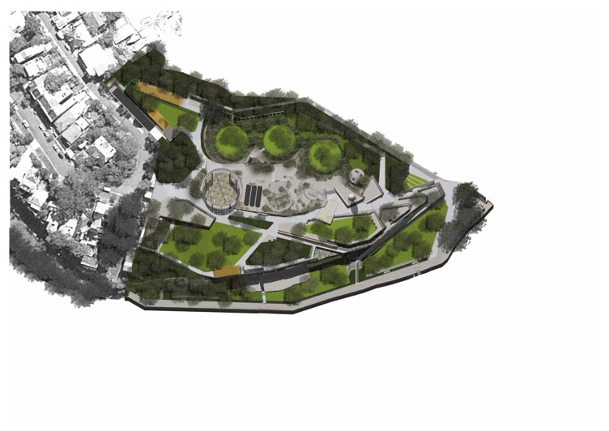

Ballast Point Landscape Plan ( source Sydney Harbour Foreshore Authority, Ballast Point Park Walama, booklet 2009 )

Primary author of this form

Colleen Morris

References used for completing this form

Attenbrow, V.Sydney’s Aboriginal Past: investigating the archaeological and historical records UNSW Press, Sydney, 2002.
Harding, Laura and Scott Hawken, ‘Ballast Point Park’, from ArchitectureAU, posted 2 November 2009 (https://architectureau.com/articles/ballast-pointpark-2/)
Landscape Architecture Australia, November 2009, (Issue 124)
Simon, Katrina ‘Ballast Point Park’, ArchitectureAU May 2010 (Vol 99,No3)

Solling, Max & Peter Reynolds, Leichhardt On the margins of the City, Allen & Unwin, 1997, St. Leonards.
Sydney Harbour Foreshore Authority, Ballast Point Park Walama, booklet 2009
Tropman and Tropman Architects, ‘Ballast Point, Birchgrove, Review and Analysis of the Former Caltex Site’ prepared for SHFA, August 2004

http://www.balmainassociation.org.au/newsletters/contents/312%20200909.pdf

Signed by Author

Signed by copyright holder(s) of image(s)

Additional photographs, maps or other images

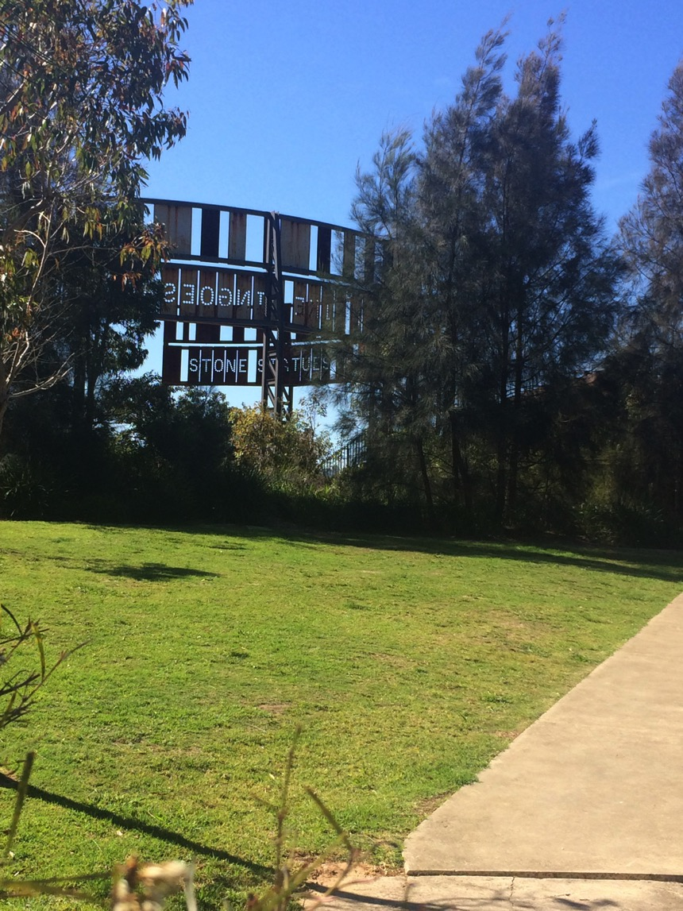
Looking toward Tank 101 through eucalypts and casuarinas. ( Photo James Quoyle 2016)

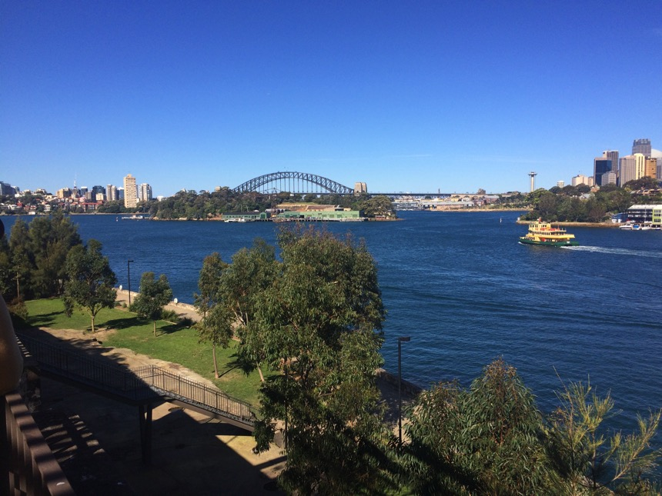
A view from the eastern side upper terrace level toward Goat Island (Me Mel) and Sydney Harbour Bridge ( Photo James Quoyle 2016)
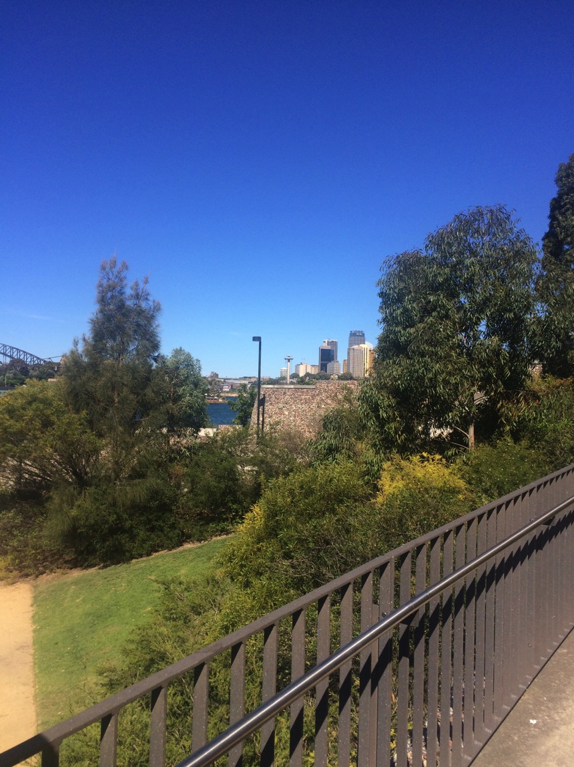
A view across the park indicates the deatiling of walls, lighting and metal railings.

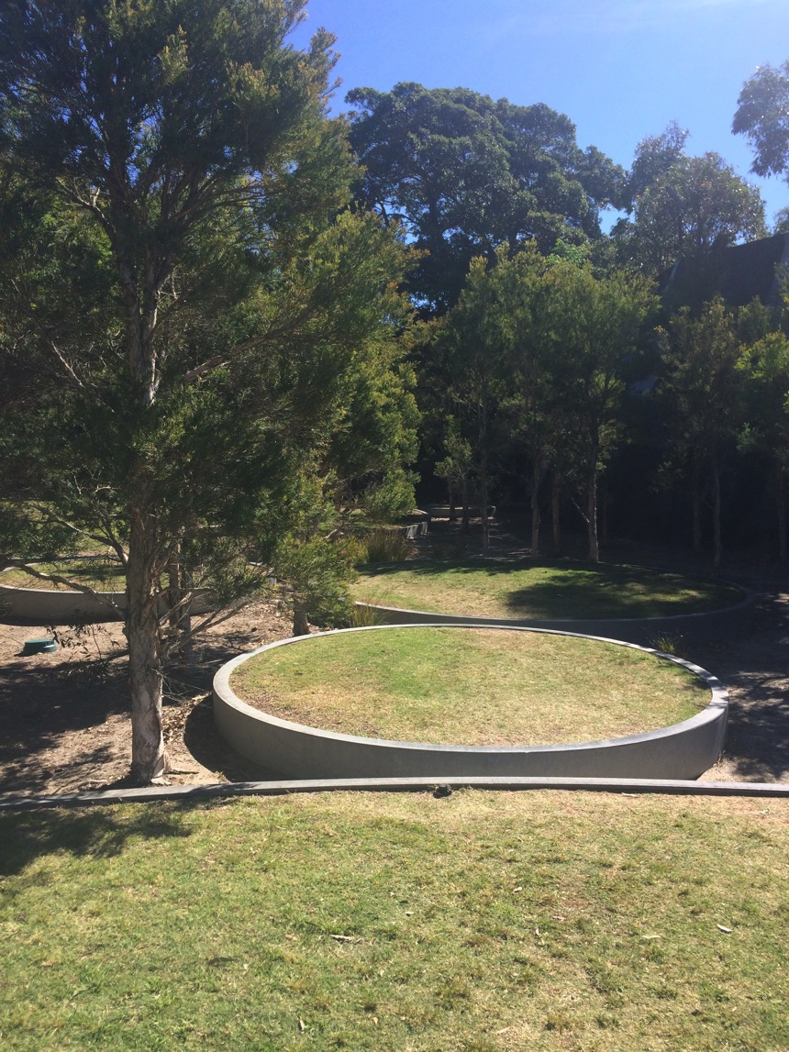
Circular grassed elements, which interpret the locations of former tanks used by Caltex on the site are surrounded by melaleucas in one of the more enclosed spaces. (Photo :James Quoyle 2016).
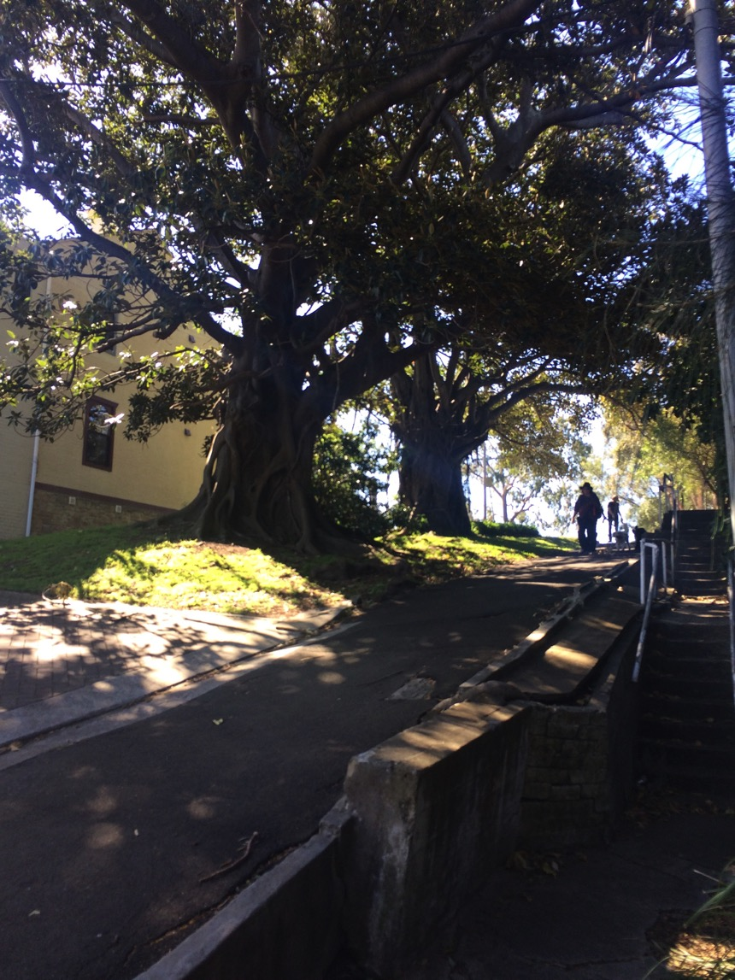
The Ronald Street Reserve walkway and mature figs. ( Photo: James Quoyle 2016)

Tropman and Tropman, p. 8.
Evening News, Sydney, Wed 3 Nov 1926, p.6; SMH, Thu 11 Nov 1926, p.10
Tropman and Tropman, op. cit. p.16
https://www.leichhardt.nsw.gov.au/.../3615/TomUrenTrail-brochure-for-web.pdf.aspx
Sydney Harbour Foreshore Authority, Ballast Point Park Walama, booklet 2009
http://www.aila.org.au ‘Transformative Parks that are Changing Australia’ Media Release 27 October 2016,

